Wedding Venues where Denise has Performed
A’bulae
All Saints Lutheran Church, Cottage Grove
Ann Bean Mansion, Stillwater
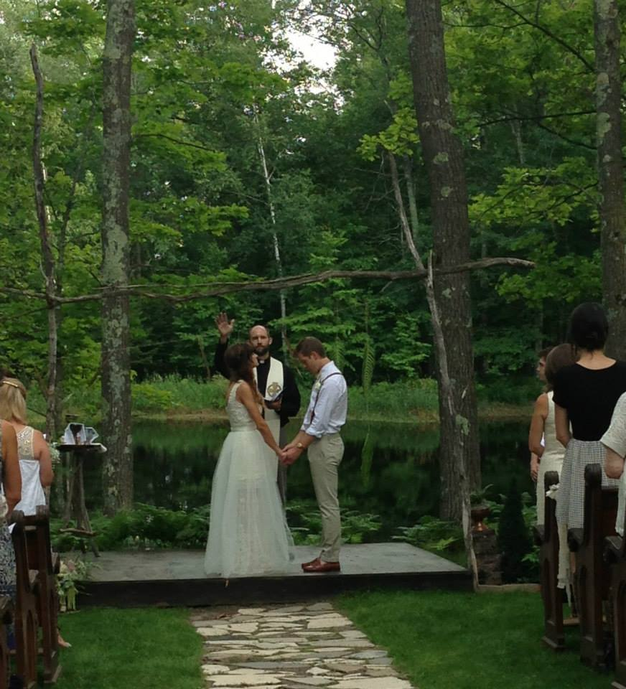
Arboretum Perennial Gardens
Aria, Minneapolis
Arneson Acres, Edina
Assumption Catholic Church, St. Paul
Aurora Staples Inn
Bear Path Golf Course, Eden Prairie
Bethlehem Lutheran, Bayport
Black Bear Crossing, Como Park
Bunker Hills Golf Club, Coon Rapids
Camrose Hill
Carlson Towers Rotunda, Plymouth
Cathedral of St. Paul
Centennial Lakes, Edina
Chateau St. Croix Winery, St. Croix Falls, Wisconsin
Como Conservatory, St. Paul
Christ Lutheran Church, Marine
Dellwood Country Club
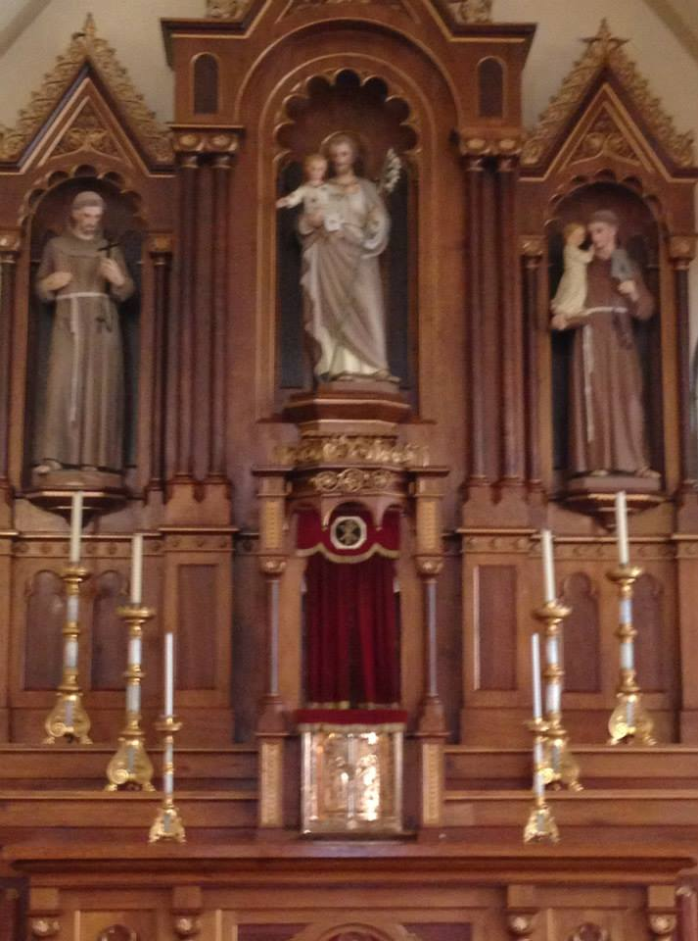
Earle Brown Heritage Center, Brooklyn Center
Edina Country Club
Edinberg
Fairhaven Farms, Fairhaven
First Lutheran Church, White Bear Lake
Gallery 13, Minneapolis
Gibbs Farm, St. Paul
Grand Casino Hinckley
Guardian Angels Catholic Church, Oakdale
Harriet Island, St. Paul
Hazelden
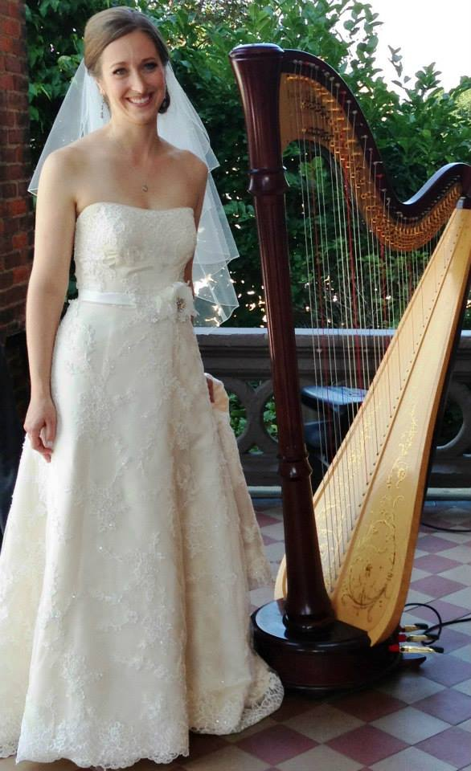
Historic Hope Glen Farm, Cottage Grove
Historic Courthouse, Stillwater
Historic Wesley Center, Minneapolis
History Center, St. Paul
Holy Cross Lutheran Church, Minneapolis
IDS Windows on Minnesota
Intl. Guard Base Chapel, 133rd Airlift Wing
Irvine Park, St. Paul
Itasca Building, Minneapolis
James J. Hill Library, St. Paul
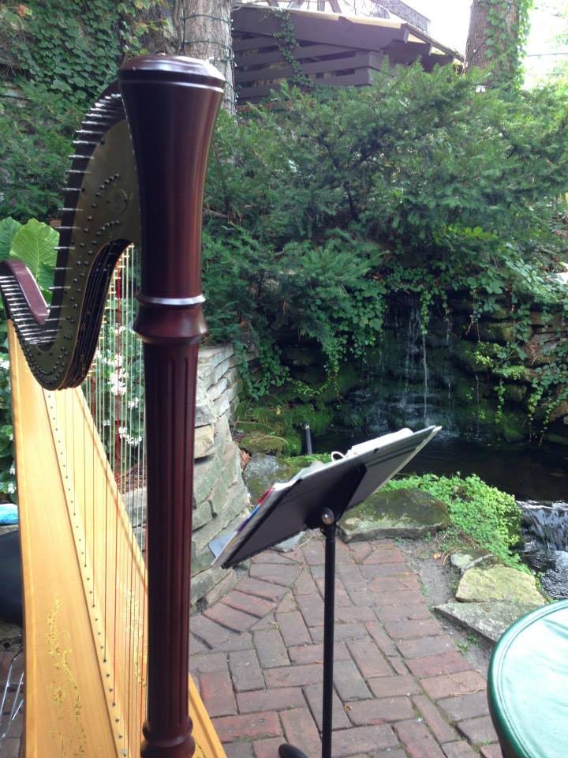
James J. Hill House, St. Paul
Jax Café, Minneapolis
Julianne James Place, Mason
Kozlak’s North Oaks
Lake Elmo Inn
Lakewood Chapel, Minneapolis
Landmark Center
LeMeridian Chambers, Burnett Gallery, Minneapolis
Lowell Park, Stillwater
Lurcat, Minneapolis
Lord of Life Lutheran Church, St. Paul
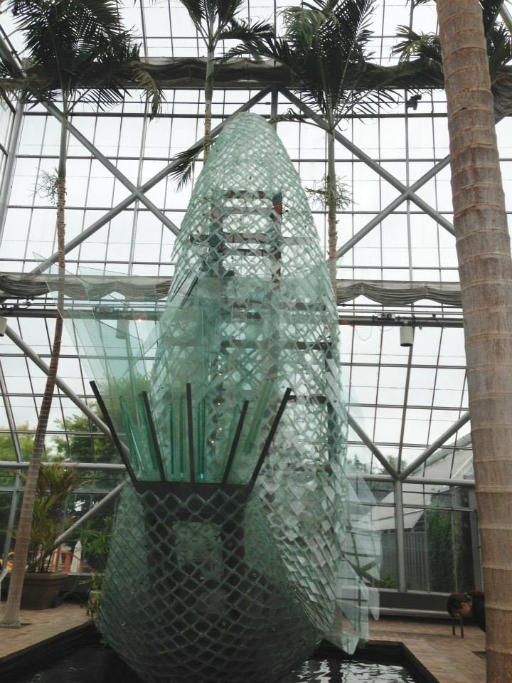
Lowell Inn Stillwater
Lowertown Event Center, St. Paul
Macphail Center for the Arts
Marriott Northwest, Brooklyn Park
Mendakota Country Club, Mendota Heights
Millenium Gardens, Minneapolis
Minneapolis Institute of Arts
Minneapolis Sculpture Garden
Minnehaha Falls Park
Minnesota Zoo
Mississippi Dunes, Cottage Grove
Muriel Sahlin Arboretum, Roseville
Mustang Tavern, New Brighton
Nazareth Chapel, Northwestern University, St. Paul
Oakridge Conference Center, Chaska
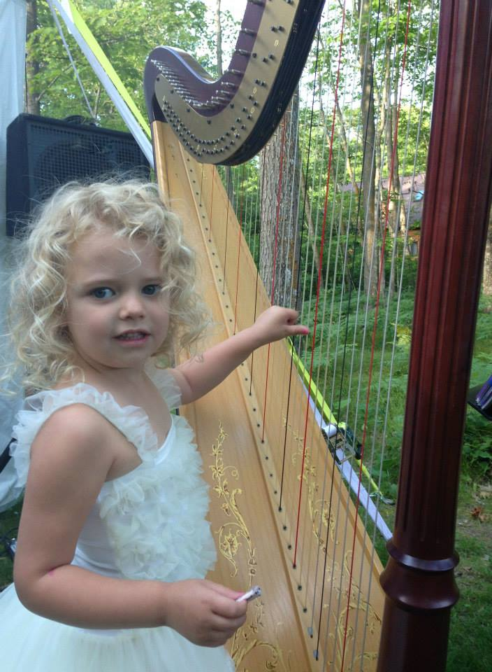
Panola Valley Gardens, Lindstrom
Peace Rock Garden, Lake Harriet
People’s Congregational Church, Bayport
Prairie Log Village Church, Hastings
Prom Center, St. Paul
Radisson Blu, Minneapolis
Radisson Roseville
Raspberry Island, Minnesota Boat Club, St. Paul
Renaissance Fair Grounds
Rice Park, 317 on Rice Park, St. Paul
River Oaks Country Club, Cottage Grove
Rivertown Inn, Stillwater
Science Museum
Semple Mansion, Minneapolis
St. Andrew’s Episcopal Church, Stillwater
St. Croix Majestic Star, Stillwater
St. John’s Episcopal, St. Paul
St. John Vianney
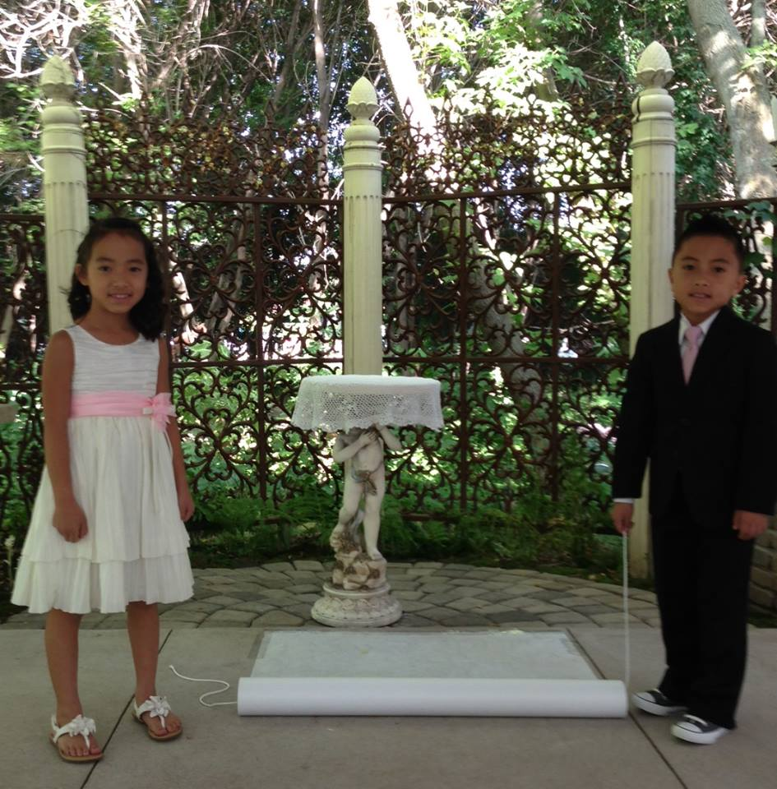
St. Mark’s Lutheran Church, North St. Paul
St. Mary’s Church, Stillwater
St. Michaels Church, Stillwater
St. Peter’s Catholic Church, North St. Paul
St. Stephens, Edina
St. Thomas More, St. Paul
St. Paul Hotel, St. Paul
St. Pius X, Zimmerman
Shepherd of the Valley Lutheran Church Afton
South Shore Trinity Lutheran Church, White Bear Lake
Stonebrooke Golf Club
Summit Manor, St. Paul
The Depot, Minneapolis
The Phipps, Hudson Wisconsin
The Waters, Edina
Trellis Weddings
Tria Restaurant, North Oaks
Trinity Lutheran Church, Stillwater
Unitarian Church River Falls
University of Minnesota, various locations
The Waters, Edina
The Wilds, Prior Lake
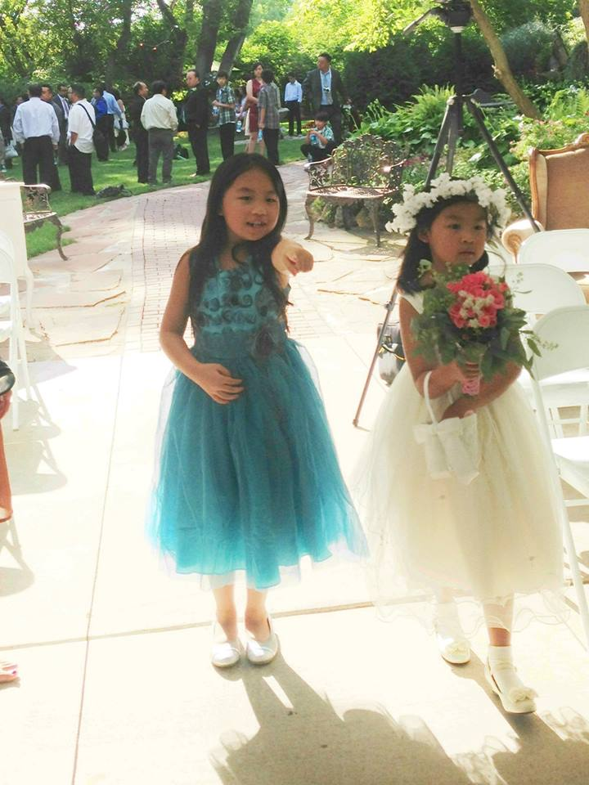
TPC Twin Cities, Blaine
Trellis Weddings, Stillwater
Union Congressional Church, Elk River
Union Depot, St. Paul
University Club, St. Paul
University Club, Summit Avenue Clubhouse
University of St. Catherine
University of St. John’s
University of St. Thomas
Van Dusen Mansion, Minneapolis
Water Power Park, Minneapolis
Water Street Inn, Stillwater
Weyerhaeuser Chapel, Macalester College
Winehaven Winery, Chisago City
Women’s Club, Minneapolis
Woodbury Lutheran, Oakhill Campus, Stillwater
YMCA Woodbury

